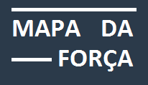

# Mapa da Força - Project

**Project Information**

Development environment: Visual Studio 2017  
Data Base: SQL Server  
Target Framework: .net Core 2.1  
Authentication System: Microsoft Identity

**Project Layers**

MapaDaForca – Application  
MapaDaForca.Model – Business layer  
MapaDaForca.Data: Data layer and DbContext  
MapaDaForca.Model – Poco classes

# Mapa da Força – Pages

## Report pages

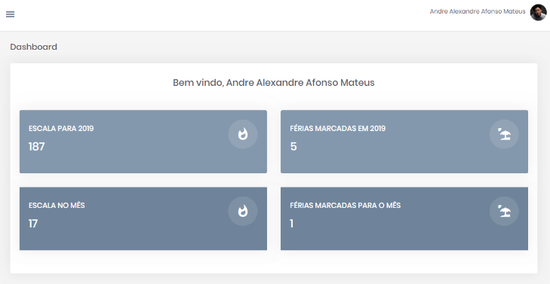

**Dashboard Page**

Main page that provides the basic info about the fireman logged during the year / month, with the possibility to redirect it to his data.

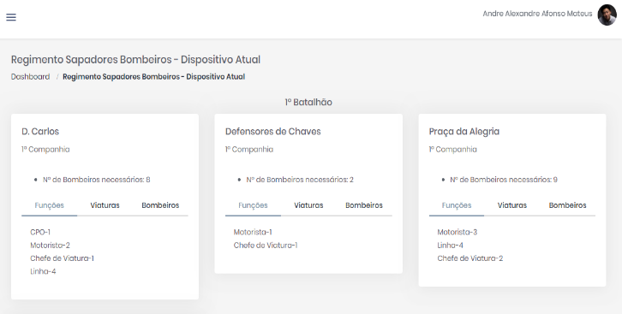

**RSB - Dispositivo**

Page that provides ordered by Batalhão the main quartel info.

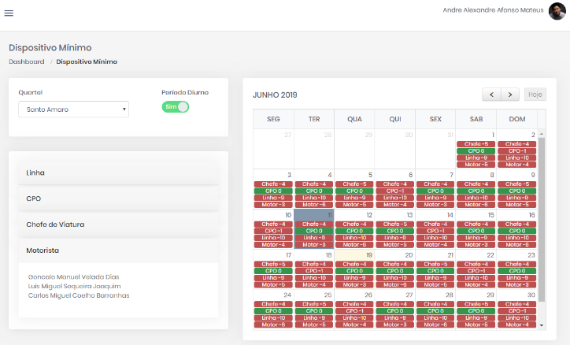**Dispositivo Mínimo**

Page that allows the selection by “Quartel” and period, a daily overview on the amount needed by function. Where the red option indicates a worker pendency, the yellow option indicates a number greater than required and the green option indicates a conformity between what is needed and what was allocated.

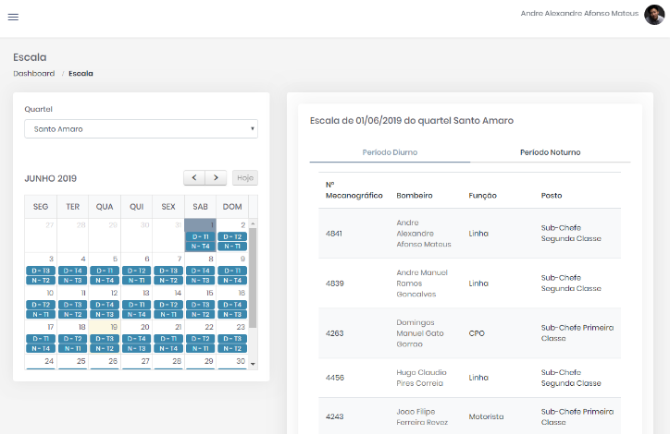

**Escala**

Page that allows the selection by “Quartel” a daily overview by period with the firemen allocated. More them this is possible to see in this page the “Turno” by day.

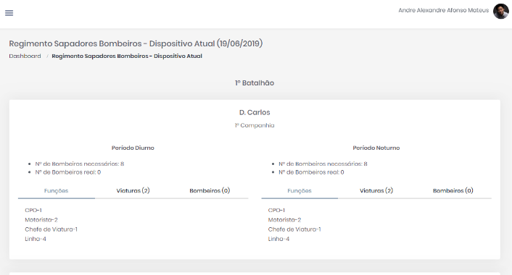

**RSB – Dispositivo (Hoje)**

Page that provides ordered by Batalhão the main quartel info considering the current day.

## Setup Pages

### Escala

* **Tipo da Ausência –** List that provides a complement of the Escala type.
* **Escala vs. Turno –** A relation between the Escala and the turns, where each day just can have 2 turns, one for the diurnal period and another for the night period.

### RSB

* **Batalhão –** List of Batalhão.
* **Companhia –** List of Companhia.
* **Quartel –** List of Quartel, where is possible to associate the Viaturas (Vehicles) used in each Quartel.
* **Tipo da Viatura –** List that provides a Viatura type, where is possible to setup the quantity and functions necessary for each type.
* **Viatura –** List of Viatura (Vehicle).

### Corpo Operacional

* **Bombeiro –** List of Bombeiro (fireman), where is possible to associate the functions that the fireman can execute, and more than this is there where is possible to setup the schedule of each fireman.
* **Função –** List of Função.
* **Posto –** List of Posto.